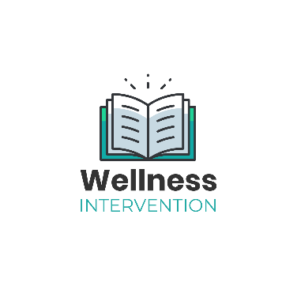
Wellness Intervention
Course and Instructor Evaluation
Your honest and sincere evaluation of this course helps ensure that the programs offered through Well-being Safety Assessments are of the highest caliber and meet or exceed your training needs. Thank you.

Title of Course: _________________________________________
Instructor: _____________________________________________
Dates: _________________________________________________

Materials | 1.Printed materials were well organized 5 4 3 2 1 n/a  2.Printed materials were complete 5 4 3 2 1 n/a  3.Printed materials were readable 5 4 3 2 1 n/a  4.Visual materials were related to course 5 4 3 2 1 n/a  5.Visual materials were of good quality 5 4 3 2 1 n/a
Course | 6.Covered subjects you thought it would 5 4 3 2 1 n/a  7.Was a reasonable length 5 4 3 2 1 n/a  8.Contributed to your knowledge & skills 5 4 3 2 1 n/a  9.Related to your needs 5 4 3 2 1 n/a  10.Was worth recommending to others 5 4 3 2 1 n/a
Instructor(s) | 11.Related course materials to class needs 5 4 3 2 1 n/a  12.Knew subject thoroughly 5 4 3 2 1 n/a  13.Made course objectives clear 5 4 3 2 1 n/a  14.Stayed on topic/subject 5 4 3 2 1 n/a  15.Answered questions completely 5 4 3 2 1 n/a  16.Started and ended at appropriate times 5 4 3 2 1 n/a  17.Handled self in a professional manner 5 4 3 2 1 n/a
Online | 18.Online links worked properly 5 4 3 2 1 n/a  19.Online video presentation worked well 5 4 3 2 1 n/a
Suggestions | 20.How could the instructor improve the class?  21.How could the course content be improved?  22.If you could make one change to the course what would you add, subtract or delete?

